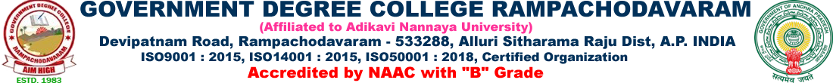

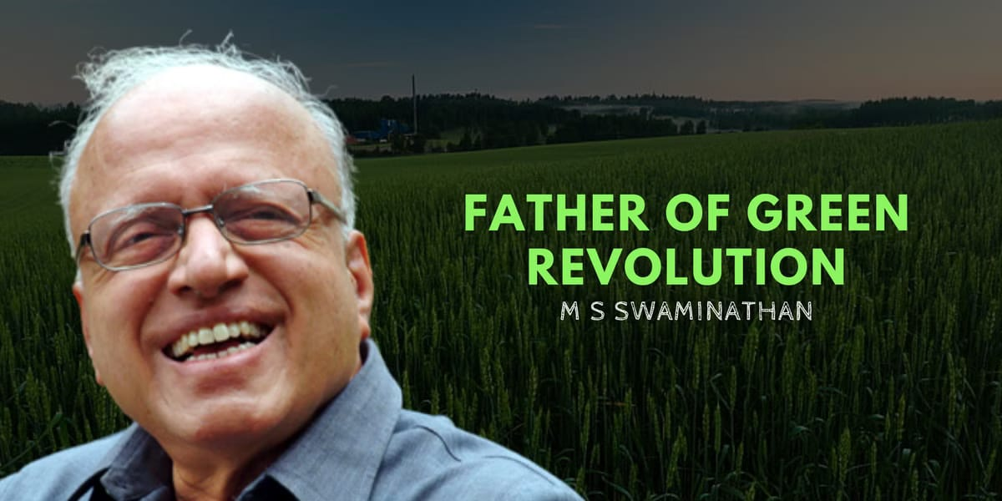

**Dr MS SWAMYNATHAN BIRTH ANNIVERSARY 2024**

**Government degree college Department economics was conducted the Birth Anniversary celebrations of Dr. Swamy Nathan. He was father of Green Revolution in India. He was developed and cleared the Agricultural Department. In this programme Smt M. Siva Kumari madam preside the on the function another guest sri K.G Venkatesh lecturer the chemistry, and also participated Biological faculty. The Birth celebration is Dr. Swamy Nathan programme all students (Science and art).**

